**INDIAN STATISTICAL INSTITUTE**

***ASSIGNMENT 1***

**NAME:** SUBHRAJYOTY ROY

**ROLL:**  BS-1613

**DEPT:** B.STAT YEAR- I

**SUBJECT:** STATISTICAL METHODS I

* **INTRODUCTION:**

This assignment concerns with basic analysis and interpretation of data about the school life educational overview in India in the year 2007-08. This also demonstrates how each individual states distributed trained teachers among various degree of educational standards in schooling in 2007-08.

* **COLLECTION OF DATA:**

The data used in the assignment are secondary data collected from a governmental website which was uploaded there probably from Department of Education, Ministry of Human Resource Development.

* **SUMMARY OF DATA:**

The collected data is then scrutinized and analyzed to calculate the central tendency, measures of dispersion and kurtosis and skewness. The summary of the data is represented through pictorial diagrams.

Here, the summary of teachers' distribution in different educational standards of schooling in the year 2007-08 is presented through a table below (Table-1). In this table, the percentage of trained teachers and the distribution of female teachers is also included.

**TABLE-1**

**Summary of Teachers' Distribution in Different Standards of School in India (2007-08):**

 **Source :** Department of Education, Ministry of Human Resource Development

* Primary schooling means till 4th Grade, Middle schooling includes 5th Grade to 8th Grade, High schooling includes all the schools having 9-10th standard, and Higher Secondary schooling implies 10+2 standard.

** Since the data collected about trained teachers are in Percentage(%), doing Geometric mean is the only feasible and satisfactory central tendency representation.

Here, another table (Table-2) is presented which shows how the teachers were distributed in different states, presenting mean , standard deviation, skewness and kurtosis.

**TABLE-2**

**The Summary of Statewise Distribution of Teachers:**



*\* The different colours in the rows represent which zone of India does the state belong to, i.e. Northern or Southern or Eastern etc.*

Here, some pictorial diagrams (mainly bar plots) are presented for better understanding of the data.

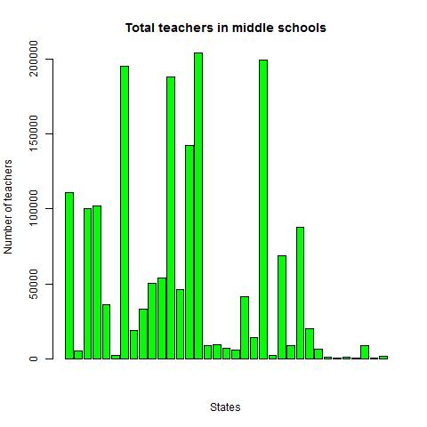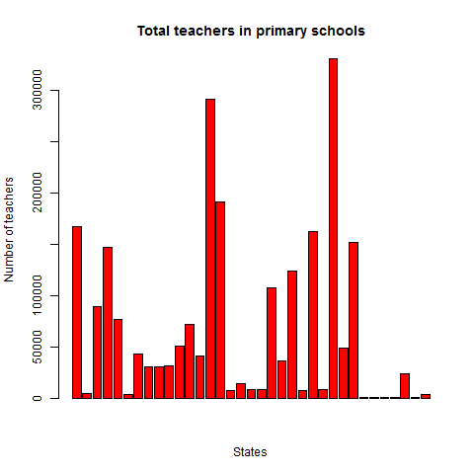

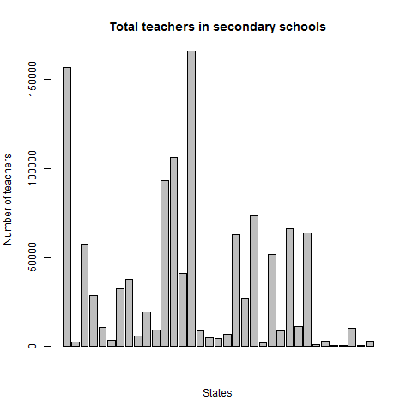

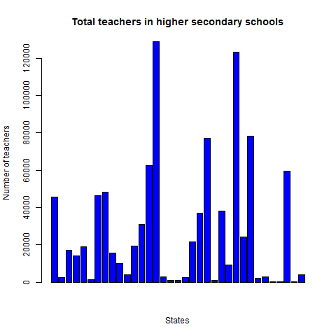

The above figures are the distribution of total teachers in different states. Below, I present some more figures related to the percentages(%) of female teachers and trained teachers in some selected states. These, hopefully, shows a better view to the quality of education provided in those states.

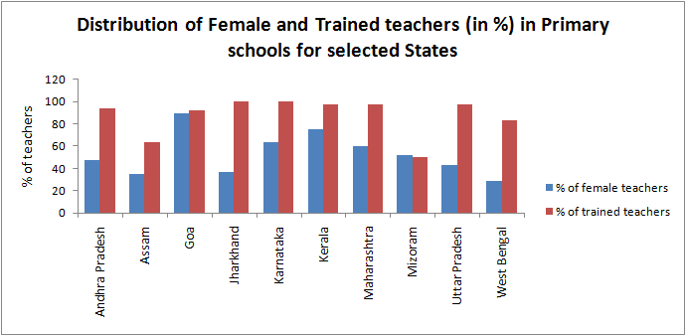

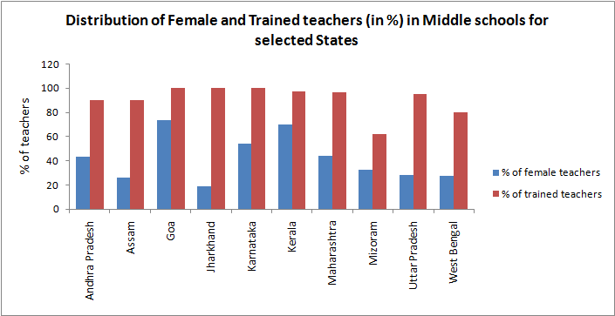

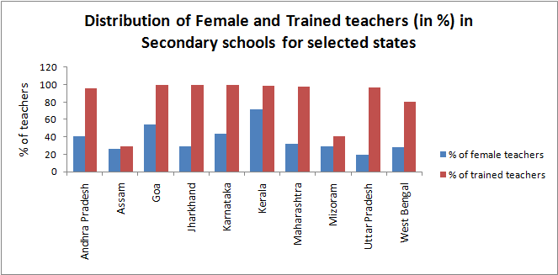

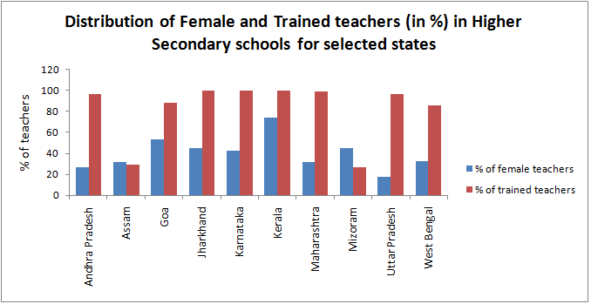

* **INTERPRETATION OF DATA:**

From the above analysis of data, we understand the following:

* In TABLE-1, we see that overall **1/3rd** of the total teachers are females. We can also see that for middle school level, the ratio of female teachers to the whole population was less while in other educational level the ratio remained almost same.
* From TABLE-1 we deduce that on an average **75%** of the teachers were trained in 2007-08. Moreover, the percentage of trained teachers was more in higher educational levels.
* From TABLE-2, we get that the eastern regional states such as Arunachal Pradesh, Mizoram, Manipur, Nagaland, Sikkim had relatively low amount of teachers in their schools. We also see that Goa also had this feature. We may suspect that this is due to low population in those states. Clearly, due to the same reason we see that Maharashtra, Madhya Pradesh, Andhra Pradesh, Uttar Pradesh had relatively more teachers.
* From the summary in TABLE-2, we see that in Andhra Pradesh, Assam, Haryana, Himachal Pradesh, Maharashtra the coefficient of skewness of the distribution of teachers in different school levels were **negative.** This shows that in these states education system is focused towards Higher education. We also see that in West Bengal, Kerala, Jammu & Kashmir, Tamil Nadu, this measure is **positive** implying that in these states education system is more focused in Primary education.
* From TABLE-2, we also see that in each state the distribution of teachers has kurtosis measure around 2. As it is less than 3, we say that the distributions are in fact platykurtic.
* From Figure titled "Total teachers in primary schools" we see that the Statewise distribution of teachers in primary schools is bimodal. Two peaks occur at Madhya Pradesh (having 292602 teachers) and Uttar Pradesh (having 331650 teachers). Also in the Union Territories the numbers are relatively small.
* From Figure titled "Total teachers in middle schools" we see that the Statewise distribution of teachers in middle schools is multimodal. Four peaks occur at Gujarat, Karnataka, Maharashtra and Rajasthan. (**It is quite surprising that on an average Rajasthan had a moderate amount of teacher, but it holds a modal position in terms of middle schools.**) Also Punjab holds a smaller peak in the distribution.
* From Figure titled "Total teachers in secondary schools" we see that the Statewise distribution of teachers in secondary schools is bimodal. Two peaks occur at Andhra Pradesh (having 156887 teachers) and Maharashtra (having 166221 teachers). Two smaller peaks occur at Kerala and Karnataka (each having around 100000 teachers).
* From Figure titled "Total teachers in higher secondary schools" we see that the Statewise distribution of teachers in higher secondary schools is bimodal. Two peaks occur at Uttar Pradesh (having 123327 teachers) and Maharashtra (having 129062 teachers). Three smaller peaks occur at West Bengal and Rajasthan and Delhi. (**Which shows among the Union Territories, Delhi is richest in terms of education**.)
* From the figures titled "Distribution of Female and Trained teachers in (Primary/Middle/HS) schools for selected States", we see that percentage of **trained** teachers in Andhra Pradesh, Jharkhand, Karnataka, Kerala, Maharashtra, U.P. are high, while Mizoram and Assam stands low in this section. West Bengal had a moderate amount of trained teachers. Also, while Assam is relatively low in terms of trained teachers in different grades of schools, there are **90% trained teachers in Middle schools** **in Assam** which shows middle school level education is strong in that state.
* From the figures titled "Distribution of Female and Trained teachers in (Primary/Middle/HS) schools for selected States", we see that percentage of **female** teachers in Goa and Kerala are quite high. In West Bengal, U.P. and in Jharkhand, this percentages are relatively low. **In** **Maharashtra there were 50% female teachers on an average.**
* **CONCLUSION:**

From the interpretation of the data, we get that in 2007-08 year, some states were in good condition in terms of education, while in some states (especially the north-eastern zone) the educational quality was poor. Even in the states with good educations, there were variant in terms of female teachers. Some conservative states has less % of female teachers, while some (mainly southern states) had more % of female teachers. We also see that in terms of quality of education, West Bengal was at a moderate position enlightening the scope of further improvements in the education system.

---------------------